МИНИСТЕРСТВО НАУКИ И ВЫСШЕГО ОБРАЗОВАНИЯ  
РОССИЙСКОЙ ФЕДЕРАЦИИ

федеральное государственное автономное   
образовательное учреждение высшего образования  
«Самарский национальный исследовательский университет   
имени академика С.П. Королева»

(Самарский университет)

Институт информатики, математики и электроники

Факультет информатики  
Кафедра суперкомпьютеров и общей информатики

**Отчет по лабораторной работе № 5**

Дисциплина: «Enterprise Systems Development (Методы проектирования и поддержки требований к программному обеспечению)»

Тип предприятия: **«Cinema chain»**

Выполнил: Мелешенко И. С.

Группа: 6133-010402D

Самара 2022

**СОДЕРЖАНИЕ**

1 Assignment #1. Class diagram 3

2 Лабораторная работа №5 Class diagram 4

# 1 Assignment #1. Class diagram

Objective: To study the basic features for creating and editing class diagrams

Tasks

1. Study the possibility of describing the static structure of the information system. Learn how to allocate in the system of the basic classes and describe their properties and behavior. Create Class diagram. Describe at least 5 classes with relations.

2. Add Class diagram image to doc report.

3. Add table with comments:

|  |  |  |
| --- | --- | --- |
| Class name | Attributes/Methods | Data type/Comment about method assigment |
| Class1 | Attribute1 | Char[100] |
|  | Method1 | This method adds new list… |
|  | … |  |

# 2 Лабораторная работа №5 Class diagram

The chosen company type is Cinema Tickets chain.

The purpose of the system: online purchase of cinema tickets.

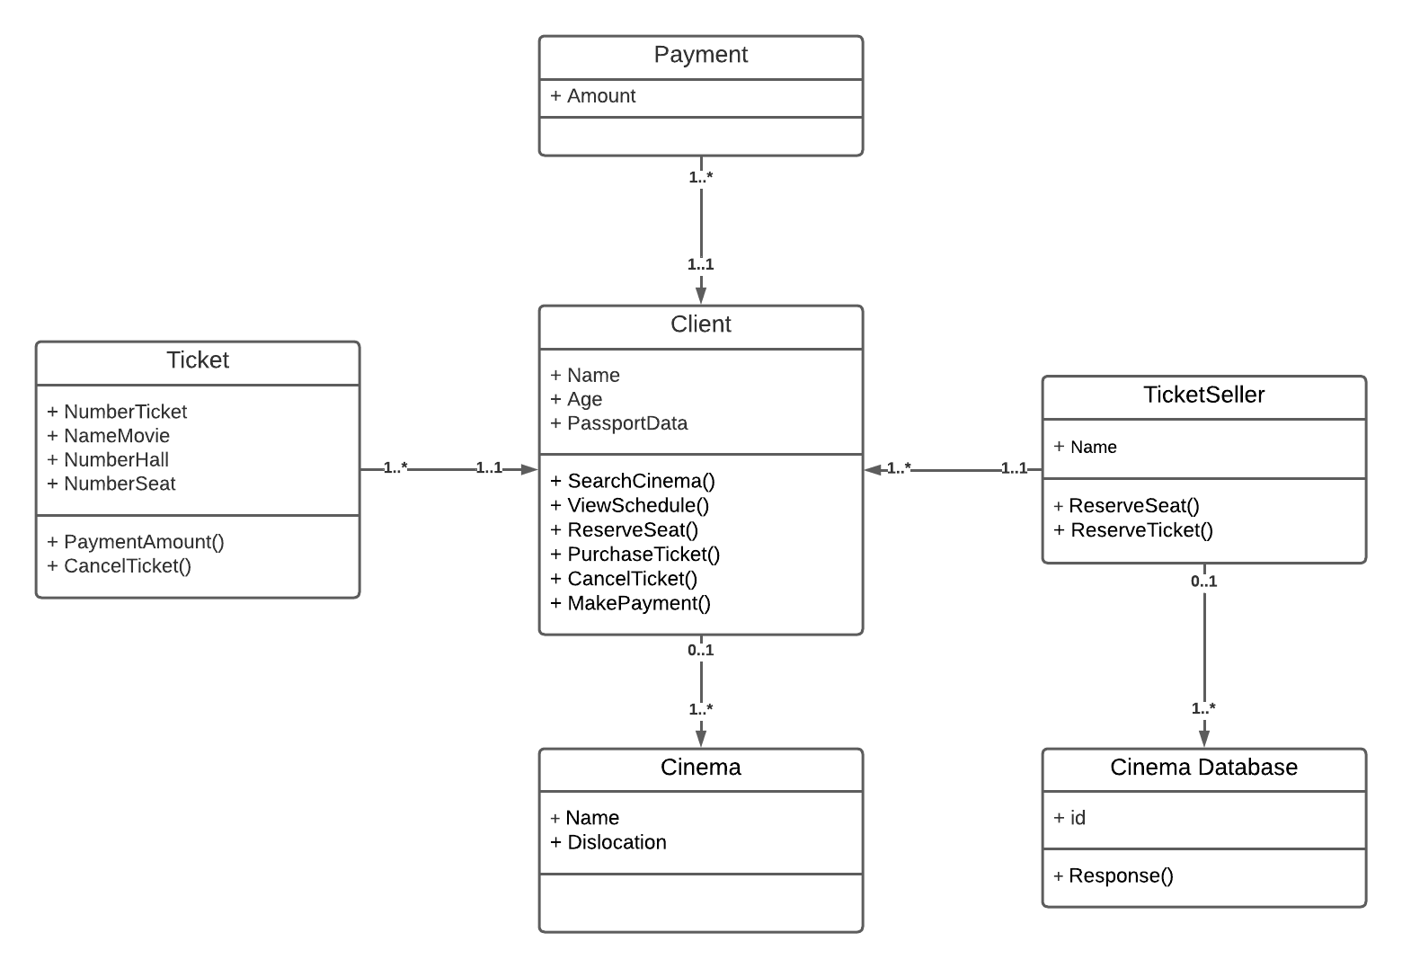  
Figure 1 - Class diagram

Table 1 - Class diagram

| Class name | Attributes/Method | Data type/Comment |
| --- | --- | --- |
| Client | Name | string |
| Age | int |
| Passport_Data | int |
| SearchCinema() | The method searches for affordable cinema |
| ViewSchedule() | The method allows you to view the schedule |
| ReserveSeat() | The method reserves a seat for the client |
| PurchaseTicket() | The method assigns a ticket to the client |
| CancelTicket() | The method detaches the ticket from the client |
| MakePayment() | The method allows the client to pay for the ticket |
| Payment | Amount | decimal |
| Ticket | NumberTicket | int |
| NameMovie | string |
| NumberHall | int |
| NumberSeat | int |
| PaymentAmount() | Method adds ticket price |
| CancelTicket() | Method nullifies the ticket |
| TicketSeller | Name | string |
| ReserveSeat() | The method reserves a seat for a specific client |
| ReserveTicket() | Method reserves a ticket for a specific client |
| CancelTicket() | Method cancels ticket |
| ReseivePayment() | The method processes the payment |
| Cinema Database | ID | int |
| Response() | The method requests a ticket from the database |
| Cinema | Name | string |
| Dislocation | string |